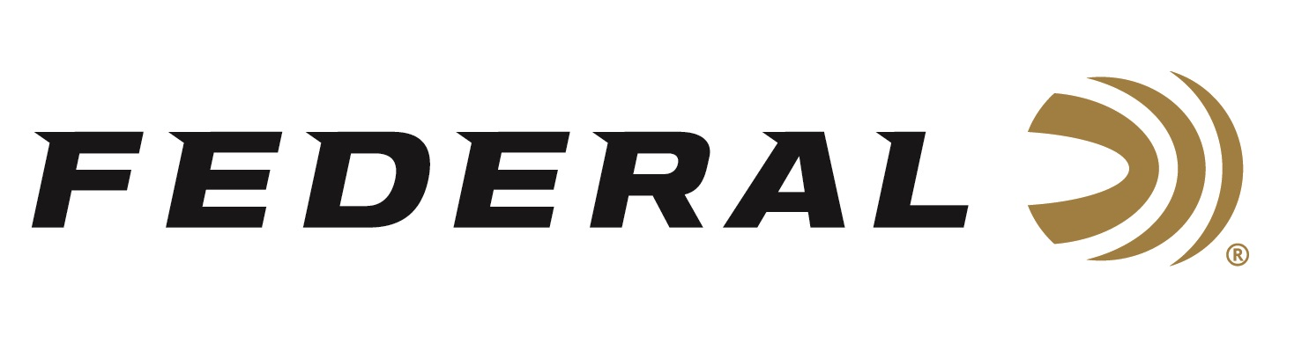

FOR IMMEDIATE RELEASE

**Federal Ammunition Sponsored Shooter Wolf Victorious at HOA Cup**

**ANOKA, Minnesota –** **June 16, 2025 –** Federal Ammunition congratulates sponsored shooter Gregg Wolf on capturing the High Over All at Federal’s HOA Cup. The three-day event took place at Game Unlimited just outside Hudson, WI concluding on Sunday, June 15, 2025, with over 160 participants.

Wolf, a Minnesota native and former World FITASC Champion, won the HOA Cup with a three-target margin over the entered field. The HOA Cup was a combination of the Main Event, FITASC, and 5-Stand scores. Wolf tied for the Main Event High Over All, won the 5-Stand event, and finished tied for second in the FITASC event. “Despite the rainy conditions, the superior crew at Game Unlimited had the courses in top shape for a fantastic event,” said Federal’s V.P. of Marketing Jason Nash. Game Unlimited will serve as host for the coming NSCA North Central Regional in August.

Shooters had the opportunity to purchase Federal’s new Master Class load at Game Unlimited. Master Class is a new competition-level sporting clay load that features a customized Podium wad which extracts peak performance from Federal’s straight-wall hull. Reliable primers, high-antimony lead shot and select propellant combine to break the most challenging targets.

Federal Ammunition products are available at dealers nationwide and online. For more information on all Federal products, visit [www.federalpremium.com](http://www.federalpremium.com).

**Press Release Contact:** JJ Reich

Senior Manager – Press Relations

E-mail: media@tkghunt.com

**About Federal Ammunition**

Federal, headquartered in Anoka, MN, is an ammunition brand of The Kinetic Group, owned by CSG, a globally diversified industrial group based in Prague (Czech Republic). From humble beginnings nestled among the lakes and woods of Minnesota, Federal Ammunition has evolved into one of the world's largest producers of sporting ammunition. In 1922, founding President Charles L. Horn paved the way for our success. Today, Federal carries on Horn's vision for quality products and services with the next generation of outdoorsmen and women. We maintain our position as experts in the science of ammunition production. Every day, Federal manufactures products to enhance our customers' shooting experience while partnering with the conservation organizations that protect and support our outdoor heritage. Federal offers thousands of options in our Federal Premium® and standard Federal® lines, which is what makes it the most complete ammunition company in the business and helps it provide customers with a choice no matter what the pursuit.